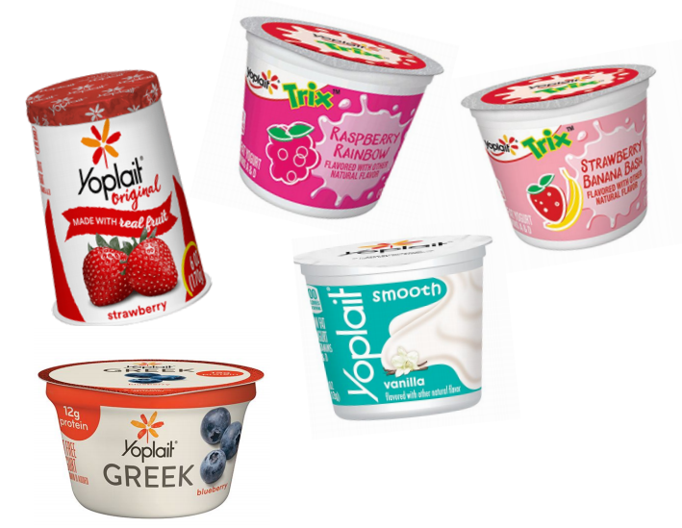
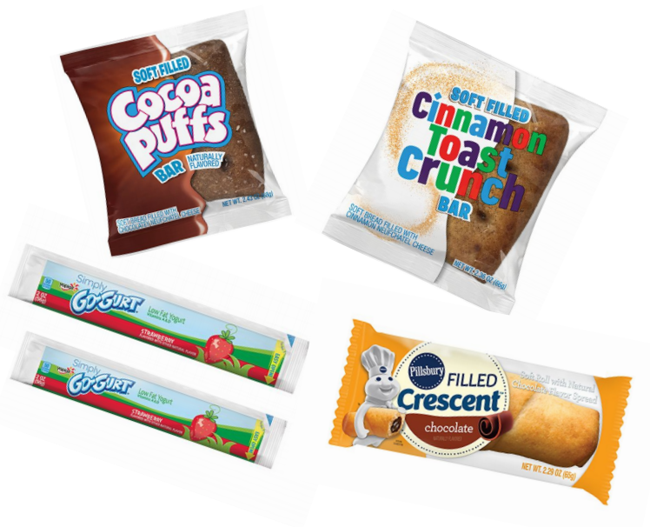
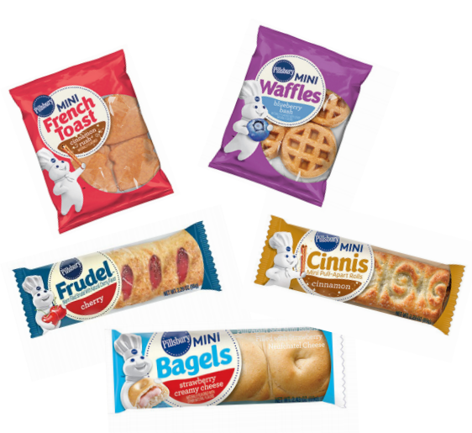

K-12 Freezer/Refrigeration Pre-Packaged Products
from General Mills.
Individually Wrapped Frozen Breakfast
Product UPC | USF Code | Product Description |  | Case/Pack | Price/Case
00-18000-27852-4 | 8872145 | Pillsbury™ Frudel™ Apple |  | 72/2.29 oz
100-18000-27851-7 | 8872137 | Pillsbury™ Frudel™ Cherry |  | 72/2.29 oz
100-18000-38399-0 | 9647413 | Pillsbury™ Mini Bagels Cinnamon Creamy Cheese |  | 72/2.43 oz
100-18000-38413-3 | 9647827 | Pillsbury™ Mini Bagels Strawberry Creamy Cheese |  | 72/2.43 oz
100-18000-33686-6 | 3639234 | Pillsbury ™ Mini Cinnis™ |  | 72/2.29 oz
100-18000-37309-0 | 3935194 | Pillsbury ™ Cinnamon Rush™ Mini French Toast |  | 72/2.64 oz
100-18000-37308-3 | 3964947 | Pillsbury ™ Triple Berry Blast™ Mini French Toast |  | 72/2.64 oz
100-18000-37732-6 | 5977151 | Pillsbury ™ Maple Burst’n ™ Mini Pancakes |  | 72/3.17 oz
100-18000-37731-9 | 3761502 | Pillsbury™ Strawberry Splash™ Mini Pancakes |  | 72/3.17 oz
100-18000-16049-2 | 9333365 | Pillsbury™ Mini Pancakes Chocolatey Chip Explosion |  | 72/3.17 oz
100-18000-32264-7 | 6960728 | Pillsbury™ Blueberry Bash Mini Waffles |  | 72/2.47 oz
100-18000-32265-4 | 6975924 | Pillsbury™ Maple Madness Mini Waffles |  | 72/2.47 oz
100-18000-10978-1 | 9504189 | Cinnamon Toast Crunch™ Soft Filled Bar |  | 72/2.36oz
100-18000-11032-9 | 4315794 | Cocoa Puffs™ Soft Filled Bar |  | 72/2.36oz
Yogurt
YOPLAIT® TRIX™ YOGURT
000-70470-17725-0 | 306654 | Yoplait® Trix™ Raspberry Rainbow |  | 48/4 oz
000-70470-17726-7 | 306647 | Yoplait® Trix™ Strawberry Banana Bash |  | 48/4 oz
100-70470-31077-7 | 1800663 | Yoplait® Trix™ Triple Cherry |  | 48/4 oz
YOPLAIT® SMOOTH YOGURT
100-70470-15676-4 | 6885920 | Yoplait® Smooth Yogurt Vanilla 4oz Cup K12 |  | 48/4 oz
100-70470-15677-1 | 7970800 | Yoplait® Smooth Yogurt Strawberry 4oz Cup K12 |  | 48/4 oz
100-70470-15675-7 | 6745454 | Yoplait® Smooth Yogurt Horchata 4oz Cup K12 |  | 48/4 oz
YOPLAIT® ORIGINAL YOGURT
00-70470-00310-5 | 1008317 | Yoplait ® Original Mixed Berry |  | 12/6 oz
100-70470-00307-5 | 8008302 | Yoplait ® Original Harvest Peach |  | 12/6 oz
100-70470-00300-6 | 2008308 | Yoplait ® Original Strawberry |  | 12/6 oz
YOPLAIT ® GREEK YOGURT
100-70470-45916-2 | 7705411 | Yoplait ® Fat Free Greek Blueberry |  | 12/5.3 oz
00-70470-45915-5 | 7705486 | Yoplait ® Fat Free Greek Strawberry Raspberry |  | 12/5.3 oz
100-70470-45913-1 | 7705254 | Yoplait ® Fat Free Greek Vanilla |  | 12/5.3 oz

