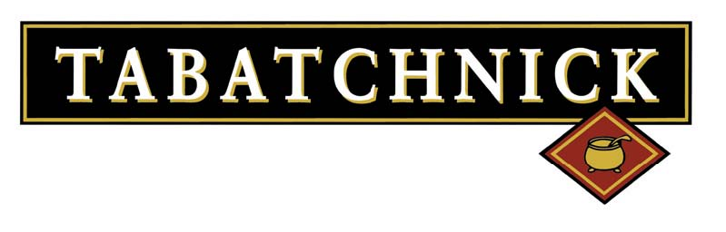

Grab-n-Go Menu

Breakfast

Oatmeal Bowl with Southern Peach Topper
Hartford’s Own Oatmeal Bowl seasoned with Brown Sugar, Cinnamon, & Sea Salt, with Southern Peach Fruit Topper

Oatmeal Bowl with Cherry Fruit Topper
Hartford’s Own Oatmeal Bowl seasoned with Brown Sugar, Cinnamon, & Sea Salt, with Cherry Fruit Topper

Oatmeal Bowl with Strawberry Fruit Topper
Hartford’s Own Oatmeal Bowl seasoned with Brown Sugar, Cinnamon, & Sea Salt, with Strawberry Fruit Topper

Lunch

WG Macaroni & Cheese Bowl
Cheddar Mac & Cheese, in a “Bakeable” Bowl, 2 M/MA & 1 OEG. Available in Whole Grain or Enriched Flour pasta

WG Jalapeno Mac & Cheese Bowl
Jalapeno Cheddar Mac & Cheese Bowl, 2 M/MA & 1 OEG, Mac & Cheese with the zesty flavor of Jalapeno Peppers

Soup Single Bowls
Single Serving Soups in “heat able” bowls, each meets ½ cup vegetable. Flavors included Minestrone, Vegetable Soup, & Creamy Tomato

Vegetarian Chili Bowls
Single Serving Vegetarian Chili in “heat able” bowls, each meets 2 M/MA & ½ cup vegetable. Gluten Free

Cheddar Cheese Cups & Chips
Single Serving, Cheddar Cheese Sauce cups, can be thaw & serve or heated, each meets 2 M/MA, may be paired with 2 OEG Tortilla Chips. Also available in Jalapeno Cheese Cups.

WG Tri-Color Tortellini Salad
Fully Cooked WG Tri-Color Tortellini can be thawed and made into Tortellini salad. Mixed with Tomatoes, Cucumbers, Olives, and Salad Dressing. Packed into single serving containers

Dessert

Frozen Fruit Cups
Comes in Strawberry or Mixed Berry Fruit Cups, made with real fruit and a little sugar, meets ½ cup Fruit

“Non- Dairy” Fruit Smoothies
Tropical Peach, Strawberry Blast, Strawberry Banana, & Blackberry Fruit Smoothies. Meets ½ cup Fruit & ¼ cup Fruit Juice and is “Smart Snack” compliant

