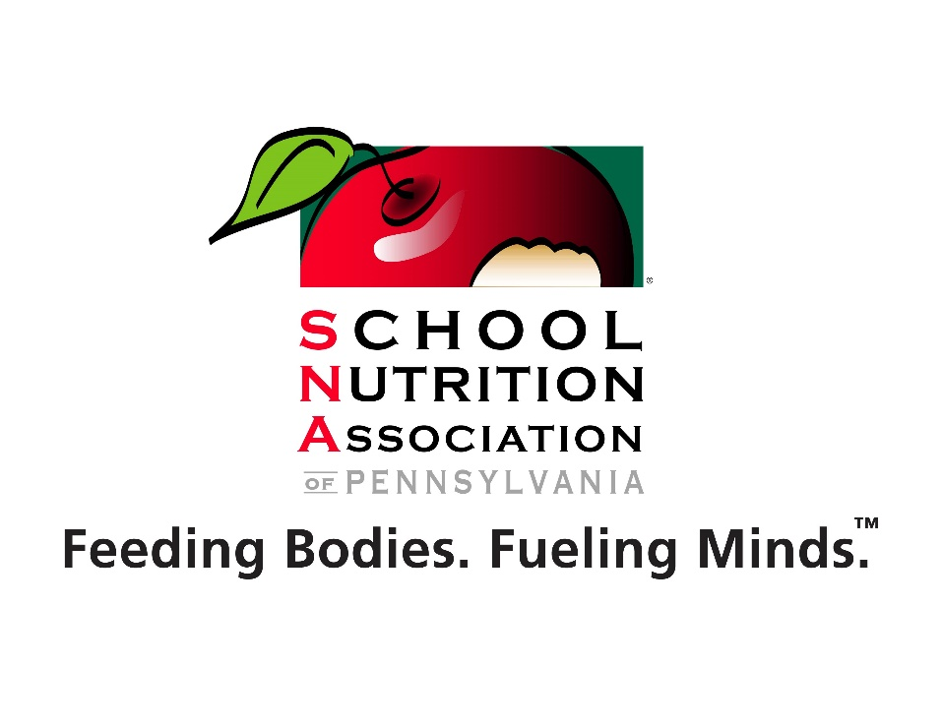
The School Nutrition Association of Pennsylvania

Essay Contest
Open to all PA Public Schools

Deadline: April 30, 2019

Essay Contest winners will present their essay at the School Nutrition Association of Pennsylvania Annual Conference President’s Dinner in Hershey, PA on July 29th at 6:00 PM

Judging Categories

Grades 5 to 8
- 250 word minimum
- 500 word maximum
- Spelling and grammar will be judged

Grades 9 to 11
- 250 word minimum
- 500 word maximum
- Spelling and grammar will be judged

One Grand Prize for each grade level category.

(4) tickets to Hershey Park
(1) night stay for (4) people

Essay Topic – Students should write about both topics below.

- Why are school meals an important part of the school day?

- Describe how receiving school meals has had an impact on your education.

Deadline: April 30, 2019

Email entry to: executivedirector@snapa.org

The School Nutrition Association of Pennsylvania
Essay Contest Form

Name: | School District:
Home Address:

Home City

Home Zip

Primary Contact Phone:

Email Address:
Judging Category 5-8 Grade 9-11 Grade
Why are school meals an important part of the school day? (min. 250 words- max. 500 words) Use additional sheet if necessary.

Describe how receiving school meals has had an impact on your education. (min. 250 words- max. 500 words) Use additional sheet if necessary.

Parent or Guardian Signature: _____________________________________Date:____________________________

